AI Smart Customer Support System

INTRODUCTION
Customer support plays a crucial role in every industry, especially in sectors like e-commerce, banking, telecommunications, healthcare, and IT services. In a broader sense, traditional customer service systems depend heavily on manual handling, which leads to slow response times, inefficiency, and inconsistent user experience. With a growing number of customers and service requests, organizations face difficulties in managing queries, prioritizing issues, understanding customer emotions, and resolving problems effectively.
Artificial Intelligence (AI) has become a powerful solution to address these challenges. AI-based systems can automate repetitive tasks, understand user messages using Natural Language Processing (NLP), classify issues, and provide instant responses through chatbots. Modern AI-driven helpdesks also analyze sentiment, detect intent, and prioritize critical customer issues to deliver faster, more intelligent support.
Narrowing down to our topic, current customer support platforms face major problems such as lack of automation, absence of sentiment analysis, manual ticket categorization, and no intelligent escalation. Our project aims to build a smart customer support system that integrates AI-driven chatbot replies, automated ticket creation, sentiment detection, issue classification, priority prediction, and an admin analytics dashboard.
Applications of AI-based Customer Support:
- E-commerce order support
- Banking/Financial complaint management
- IT Helpdesk & Technical support
- Telecom service support
- Hospital & healthcare service queries
- Government grievance systems
RELATED WORK
Paper 1: Summary + Limitation
C. S. Kanimozhi Selvi et al., “Customer Support Ticket Categorization and Prioritization Using NLP,” INCOFT 2025.
This paper proposed an NLP-based system for categorizing tickets and predicting ticket priority. Machine learning algorithms were used to classify issues into different categories.
Limitation:
The system focused only on ticket categorization and priority prediction. It did not include chatbot interaction, sentiment analysis, or real-time user support.

Paper 2: How it Tackles Limitation of Paper 1 + Summary + Limitation
Riyanto Jayadi, “Sentiment Analysis of Digital Customer Service Helpdesk Tickets: A Comparison between BERT and SVM,” IEEE 2024.
This research addressed the emotional aspect of customer messages by performing sentiment analysis. It compared SVM and BERT models for understanding user emotions in helpdesk tickets.
How it addresses Paper 1 limitations:
This paper introduces emotional intelligence, helping understand whether customers are angry, frustrated, or satisfied — an aspect missing in Paper 1.
Limitation:
The research concentrated on sentiment analysis alone and did not integrate chatbot automation or ticket creation workflows.

Paper 3: Overcoming Paper 2 limitations + Summary + Scope for Implementation
Priya Kumari et al., “Online Chatbot Based Ticketing System,” IJSRET 2024.
This paper proposed a chatbot-based helpdesk where unresolved queries are converted into tickets. It demonstrates automated responses using rule-based logic and AI.
How it overcomes Paper 2:
It adds automation by including chatbot interaction and ticketing workflow, improving user experience.
Remaining Scope for Implementation:
- No intent detection
- No priority prediction
- No admin analytics dashboard
- No microservice-based architecture
- Lacks scalable and modular full-stack implementation
Our project covers all these missing parts using a complete AI + full-stack solution.

PROBLEM DESCRIPTION
Traditional customer support systems are slow, manually controlled, and unable to analyze user emotions or classify their queries intelligently. Users often face delays, unresolved issues, and poor experience due to lack of automation. Support teams struggle to prioritize important problems, categorize issues correctly, and manage large volumes of tickets.
Our proposed system aims to solve these issues using an AI-driven platform that provides instant answers, automatically generates tickets for unresolved queries, detects sentiment and intent, classifies issues, predicts priority, and provides admins with a real-time analytics dashboard.

PROBLEM STATEMENT
Design and develop an “AI Smart Customer Support System” that automates customer service using chatbot interaction, automated ticket creation, sentiment & intent analysis, and admin analytics.

OBJECTIVES
Functional Objectives
- To develop an AI-based chatbot that can instantly respond to customer queries and generate tickets for unresolved issues.
- To implement machine learning models for sentiment detection, intent classification, ticket categorization, and priority prediction.
Performance Objective
- To design a scalable, efficient, and secure customer support platform offering fast response time, accurate predictions, and real-time analytics.

METHODOLOGY
System Architecture

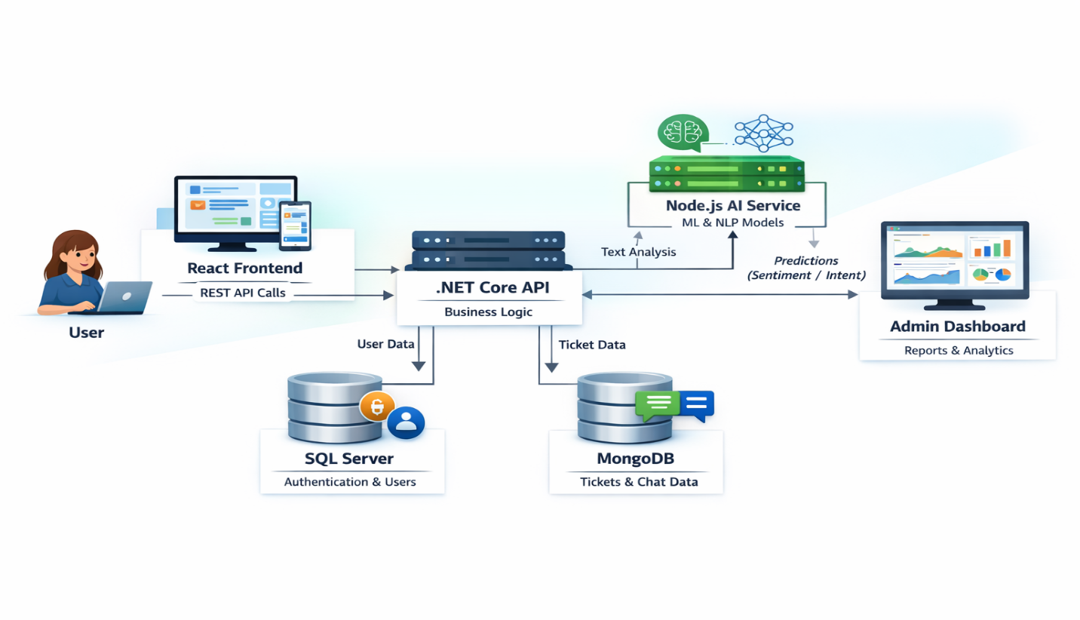

Modules
1. User Module
- Login/Register
- Chatbot communication
- Ticket creation

2. AI Processing Module
- Sentiment Analysis
- Intent Detection
- Category Prediction
- Priority Prediction
- Chatbot response generation
3. Admin Module
- View all tickets
- Update ticket status
- Monitor sentiment trends
- Analytics dashboard

FACILITIES REQUIRED
Hardware
- Personal Computer with:
  - Preferred: i5 Processor, 16GB RAM

Software
- Development Tools:
  - Visual Studio Code
  - Visual Studio 2022
  - Node.js
  - SQL Server / MongoDB
  - React.js
  - Postman
  - GitHub
Other Requirements
- Datasets:
  - Twitter Sentiment Dataset
  - Customer Support Ticket Dataset
  - Issue Severity Dataset
- Libraries:
  - NLP, ML, and AI libraries for classification

REFERENCES (IEEE Format)
[1] C. S. K. Selvi et al., “Customer Support Ticket Categorization and Prioritization Using NLP,” INCOFT 2025.
[2] R. Jayadi, “Sentiment Analysis of Digital Customer Service Helpdesk Tickets,” IEEE CENIM 2024.
[3] P. Kumari et al., “Online Chatbot Based Ticketing System,” IJSRET 2024.
[4] M. Truss and S. Boehm, “AI-based Classification of Customer Support Tickets,” arXiv, 2024.
[5] S. Uzan et al., “Optimizing Chatbots to Improve Customer Experience,” Applied Sciences, 2025.

